Autism Training Opportunities of Southwest Virginia Presents:

October 29 2012
Mark your calendar
Save the Date Register Early
TO KNOW MORE ABOUT Bill visit his site
www.williamstillman.com

William Stillman
Author of Ten Books on the Autism Spectrum
Wednesday December 5, 2012 in Blacksburg, Virginia
Save your space – register early now!

Stillman will discuss two unique and important topics:

Autism and the 90 Percent Factor: Building Authentic Relationships
In supporting individuals with autism, it may be shown that 90 percent of the work has nothing to do with those individuals but, instead, involves decoding myth-understandings among families and caregivers. When persons with autism are perceived as our intellectual peers, unlimited possibilities await us. Autism author and self-advocate, William Stillman, and New Light, Inc. staff, via video testimony, share their inspiring and revolutionary anecdotes for building authentic relationships.

The Autism Spectrum and Employment
Unemployment rates among individuals with autism range from 90 to 98 percent. William Stillman offers parents, caregivers, and self-advocates hope for viable employment via thoughts, wisdom, and strategies to poise individuals for success in potential vocational opportunities. Topics addressed include presuming intellect, sensory sensitivities, building upon passions, and new employment models.
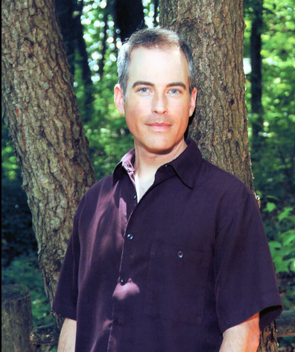
As an adult with Asperger's Syndrome, a mild "cousin" of autism, Stillman's message of reverence and respect has touched thousands nationally through his acclaimed autism workshops and private consultations. In addition to his frequent work in California, Illinois, Maryland, Delaware, Ohio, New York, New Jersey, Florida, South Carolina, North Carolina, and Virginia, William Stillman has presented at national conferences such as ASA, TASH and NATTAP, as well as conferences throughout Pennsylvania. Other presentation forums have included universities, hospitals, state centers, and schools. Stillman has a B.S. in Education from Millersville University in Pennsylvania, and has worked to support people with different ways of being since 1987. He was formerly the Pennsylvania Department of Public Welfare, Office of Developmental Program's statewide point person for children with intellectual impairment, mental health issues, and autism. In his work to support those who love and care for individuals with autism and Asperger's Syndrome, Stillman sets a tone for our collective understanding of the autistic experience in ways that are unprecedented. Autism should not be defined as an "affliction endured by sufferers," but as a truly unique and individual experience to be respected and appreciated by all. In so doing, Stillman highlights the exquisite sensitivities of our most valuable, wise and loving "teachers."

